CSIS 44692-01

Graduate Directed Project 2

**BRICK FINDER**

Team Members

Wendy Eloe

Sachin Setty

Priyanka Bonam

Bhavika Padidala

Durga Prasad Kallem

Subodh Bhargav Lakhinana

Client

Bob Machovsky, Director of Alumni Relations and Annual Giving at

Northwest Missouri State University

**TABLE OF CONTENTS**

**1 INTRODUCTION** **2**

1.1 Purpose and Scope 2

1.2 Overview, Motivations, and Impact on the Organization 2

1.3 Definitions 2

1.4 Project Website and Repository 3

1.5 Future Plans 3

**2 PROJECT MANAGEMENT PLAN** **5**

2.1 Team Organization and Schedule 5

2.2 Risk Analysis 5

2.3 Software and Hardware Requirements 5

2.4 Gantt Chart 6

**3 REQUIREMENT SPECIFICATION** **7**

3.1 Stakeholders of the System 7

3.2 Graphical UML Use Case Diagram 7

3.3 Functional Requirements 7

3.4 Non-Functional Requirements 8

**4 ARCHITECTURE** **10**

4.1 Architecture Model, Components and Style(s) Used 10

4.2 Design: Algorithms Used, Interfaces Used, Design Rationale 10

**5 TECHNOLOGY USED** **13**

**6 TESTING** **14**

6.1 Features to be Tested 14

6.2 Criteria for Passing and Failing Tests 14

6.3 Test Cases 14

**7 DELIVERABLES** **17**

7.1 Brick Finder zoning system: How it works & how to update it 17

7.2 Zone Area Maps 19

# 1 INTRODUCTION

## 1.1 Purpose and Scope

The purpose of this project is to help a user find a specific brick located in the Walk of Champions outside the Hughes Fieldhouse.

The scope of the project for this GDP team includes the development of a working prototype for the Brick Finder system over two semesters in GDP1 in spring 2019 and GDP2 in summer 2019. This shall include:

* Reading data from an Excel file or external database,
* Implementation of search functionality within the aforementioned data,
* The creation of a map and zoning system of the brick and paver locations on the Walk of Champions.

The scope of this project for our GDP1 and GDP2 class does not include adding functionality on actually purchasing a brick or any other information about alumni. We are also not deploying the brick finder system to the university network. We will give all of the files to the client so they can coordinate with marketing and make the changes that they need.

## 1.2 Overview, Motivations, and Impact on the Organization

The Brick Finder system will help the user search for the location of brick or paver by entering the name of the donor(s) or the inscription on the brick or paver in the text field. Once the user clicks on the search button, they will see a table that contains the matching results. The user can find the specific name or inscription they are looking for and can click on that particular row. By doing so, they will see a map with the zone number where that specific brick/paver can be found and an image of a brick/paver with the inscription text overlaid on it. If the user wants to print the page, they can do so by clicking on the print button that will appear on the page.

## 1.3 Definitions

**Bricks:** These are physical bricks located on the Walk of Champions. They are 4” by 8” and can contain up to three lines of personalized text.

**Donor:** The group or individual who paid for a brick or paver. Their name may or may not also be in the inscription.

**Hughes Fieldhouse:** Located on the west side of the Northwest Missouri State University campus.

**Inscription:** The actual text on bricks and pavers. This term is also used interchangeably with “personalization.”

**Pavers:** These are physical bricks located on the Walk of Champions. They are 8” by 8” and can contain up to six lines of personalized text.

**Personalization:** The actual text on bricks and pavers. This term is also used interchangeably with “inscription.”

**User:** Someone that accesses the Brick Finder system. They may or may not also be a donor.

**Walk of Champions:**  The sidewalk located to the east of the Hughes Fieldhouse where the bricks and pavers are located.

**Zone:**  The Walk of Champions is divided into 32 zones for mapping purposes: 1 through 10 North (on the north side of the sidewalk) and 1 through 10 South (on the south side of the sidewalk). We also added zones 11 NorthA, 11 NorthB, 12 NorthA, 12 NorthB, 13 NorthA, 13 NorthB for the northern fork on the east side of the Walk of Champions and 11 SouthA, 11 SouthB, 12 SouthA, 12SouthB, 13 SouthA, 13 SouthB for the southern fork on the west side of the Walk of Champions.

## 1.4 Project Website and Repository

**Repository:** <https://github.com/wendycorene/bricks>

**Website:** [https://wendycorene.github.io/bricks/](https://wendycorene.github.io/bricks/search.html)

## 1.5 Future Plans

If we were continuing to work on this project in the future or had to make recommendations for changes and improvements for a different team to do, this is what we would recommend or consider:

* Currently, users must click on the search button after typing in the text box. Hitting the enter key will reload the page. We would add functionality to make it search when hitting enter.
* We would consider taking photos of all of the bricks and pavers and displaying an image of the actual brick and paver to the user.
* We would consider adding social media sharing functionality to the website.
* The data is currently displayed in the order that it is in the Excel file. We would consider doing some sort of sorting, possibly alphabetically or in order of where bricks were on the Walk of Champions.
* The functionality to display all donors and inscriptions currently just shows the master list in no order. We would consider sorting this list or generating it on “multiple pages” to make it easier to read.
* Viewing the website on a mobile device is not quite as responsive as we would like it to be. The CSS is not as excellent as it could be. While it is functional, it could look better.
* We are currently keeping everything contained on one page and displaying and hiding divs when needed. While we like this method, we might further develop our multi-page prototype to see exactly which one really works better for this purpose.
* In the future, it would be nice to have the map actually link to Google Maps and show the location of the specific brick or the zone. This is not currently possible as Google Maps still believes that the Hughes Fieldhouse and the Walk of Champions is still a parking lot.

# 2 PROJECT MANAGEMENT PLAN

## 2.1 Team Organization and Schedule

We had no specific team hierarchy during this project. We all attempted to work as equals without a manager. We did have members that naturally took to leadership type roles when needed, but we never had an official organizational structure.

We did the majority of our development work during the spring semester and testing and polishing in the summer semester. Our goal was to have a working, functional prototype by the end of GDP2.

## 2.2 Risk Analysis

From the perspective of our student team, while working on this project we can find very little risk associated with this project. Up until this point, there has been no monetary payment for this project, so there is no associated financial risk.

The Excel data that we are using on this project is public knowledge and does not need to be kept secure to the point where no one could view the file or its contents. The data does need to be accurate, however, so the Excel data file will need to be kept in a safe location where people cannot overwrite it. We have minimized any of this risk on the end of the website as we have not added any write functionality to the Excel file. We are also only performing queries on the JSON data after accessing the Excel file, not on the data contained within the file itself.

## 2.3 Software and Hardware Requirements

We did not have any specific hardware requirements for this project. We used our student laptops (HP EliteBook 840) to develop the software.

We did not have any specific software requirements for the project. The majority of the team used Visual Studio Code as their IDE, but some also used Atom, GitHub’s IDE. We used GitHub as our repository and the majority of the team used the TortoiseGit software to make commits, but some also used Git Bash.

## 2.4 Gantt Chart

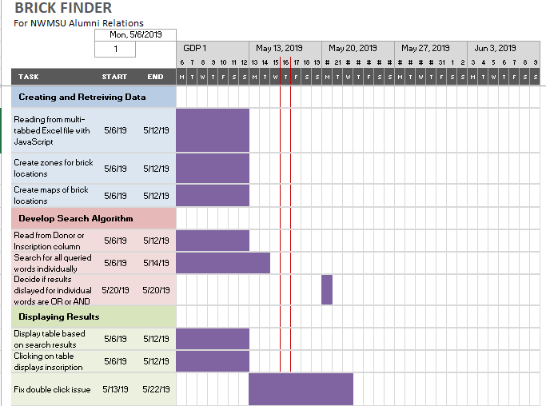

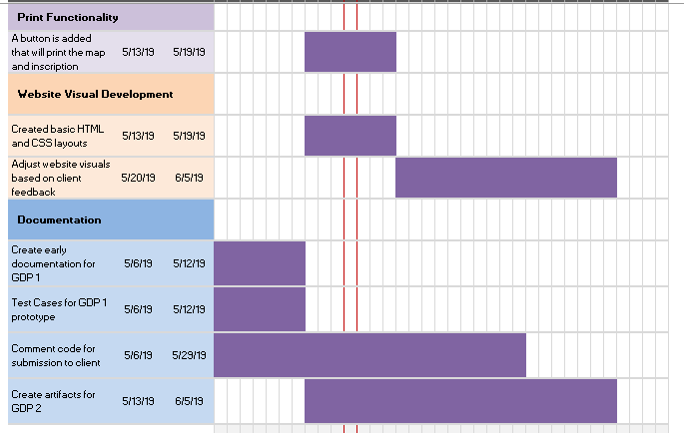

# 

# 3 REQUIREMENT SPECIFICATION

## 3.1 Stakeholders of the System

The stakeholders of the Brick Finder system is the Alumni Office at Northwest Missouri State University and their “customers” who would like to find a specific brick or paver on the Walk of Champions.

## 3.2 Graphical UML Use Case Diagram

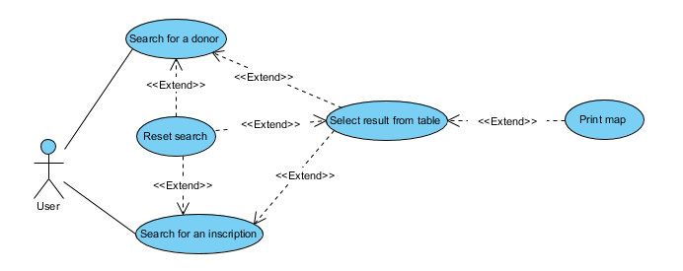

# 

## 3.3 Functional Requirements

**ID:** FR#1

**Title:** Read Excel data

**Description:** The system shall load the data from the Excel data file and convert it into JSON for easy use in the Brick Finder system.

**Dependency:** None

**ID:** FR#2

**Title:** Search through data

**Description:** The system shall accept a user-entered search term to query through the processed data.

**Dependency:**  FR#1

**ID:** FR#3

**Title:** Create results table

**Description:** The system shall populate a selectable table with the aforementioned search results containing donor name, inscription, and zone number.

**Dependency:** FR#1, FR#2

**ID:** FR#4

**Title:** Display correct map to the screen

**Description:** The system shall display the correct map on the screen that corresponds to the selected element.

**Dependency:**  FR#1, FR#2, FR#3

**ID:** FR#5

**Title:** Display correct inscription

**Description:** The system shall display the correctly formatted inscription on the screen.

**Dependency:** FR#1, FR#2, FR#3

**ID:** FR#6

**Title:** Print results

**Description:** The system shall print a page containing the correct map and formatted inscription.

**Dependency:** FR#1, FR#2, FR#3, FR#4, FR#5

## 3.4 Non-Functional Requirements

**Performance**

We have no specific measurable criteria as defined by the client for performance for this project. We strive to make the system as fast as possible in order to improve user experience.

**Reliability**

We have no specific measurable criteria as defined by the client for the reliability of this project. We will retrieve and display the information exactly as written in the Excel data file. For our page, it is the measure of how often the page can run the way toward looking through the data dependent on the information is given and showing the outcomes.

**Security**

For the purposes of this project, we have assumed that the information contained within the Excel data file is public knowledge and the content of the file does not need to be secret or secured. The file itself must not have write access to it and must be hosted on a secure server such as an NWMSU server, a GitHub repository, or similar. The file will need to be occasionally updated by someone with clearance to access where the data file is located.

**Portability**

The client specifically requested for the Brick Finder system to be responsive. We have designed this system to be accessible by the most common web browsers regardless of the device used (computer, laptop, mobile phone, etc.).

**Scalability**

We developed this project knowing that more bricks and pavers would be added in the future. Currently, there are roughly 500 bricks and pavers stored in our Excel file. We initially tested our searching functionality with test data that contained 5,000 bricks and pavers. The functionality worked the same whether we searched through 500 data entries or 5,000 and the time it took for both were comparable. As long as new brick and data information is updated in the Excel file using the same format as what is currently there, it should not be an issue for the Brick Finder system. An immediate issue that we can identify with scalability, is that if new bricks are added outside of the identified zones, new maps and zones will need to be created for them. This is something that will have to be done manually.

# 

# 4 ARCHITECTURE

## 4.1 Architecture Model, Components and Style(s) Used

The Brick Finder project primarily uses a repository/data-centered software architecture.

* Search.js - This occurs when the user clicks on the search button. It searches through the JSON data for matches.
* Maps.js - This prints the results from search.js and the correctly associated map.
* Data.js - This happens as soon as the page is loaded. It retrieves the information from the Excel file stored somewhere else and converts it into JSON data and stores that information in local memory while on the page.
* DisplayAllDonor.js - This displays every entry in the Excel file to the screen.
* HTML/CSS files
* Lib folder contains all of the libraries needed to make the code run.
* Img folder contains all of the images and maps used in the website.
* Data folder contains the Excel data file.
* Docs folder contains documentation and other files used for class.
* OldFiles folder contains a bunch of old work and sample, practice code used when creating this project. We kept it here in the repository of reference by us in the future or future groups working on this project.

## 4.2 Design: Algorithms Used, Interfaces Used, Design Rationale

**Excel Backend**

One of the main constraints for this project was the need to have as little backend functionality as possible. There have been issues in the past with GDP projects needing to be hosted on a server without having the human resources to maintain such a server. The alumni office currently uses an Excel sheet to maintain all of the data on bricks and pavers and we wanted to try and use what they already had so they did not need to learn new software either. As such, we did not use a database server to store the data for this project. We did use an Excel data file to store all of the data needed for the project and are using it like we would use a database server. This Excel file can be maintained similarly to how the Alumni office maintains it now, but it will need to be hosted somewhere on the NWMSU website. However, hosting an Excel file was the significantly preferable option for the university. We use an open source library to retrieve the information from the Excel file into a useable format. Our JavaScript file data.js reads the information from each sheet in the Excel file and converts it into JSON.

The Excel file contains two different sheets, one for bricks and one for pavers. Both contain the following row headings:

* **BrickNumber** - This is a number given to each brick and paver. This is internally used by the Alumni organization and not the project group. There are overlapping numbers between bricks and pavers. These numbers should not solely be used for identification purposes.
* **DonorName** - The name(s) of the monetary donor(s) of this brick or paver.
* **Personalization** - The specific inscription listed on a brick or paver.
* **Zone** - This is the zone location of where this brick or paver is physically located on the Walk of Champions.

Each Excel sheet also has columns that list what is located on every line of the brick or paver. The brick sheet has a column for **Line1**, **Line2**, and **Line3**, but not every brick uses every available line. The paver sheets have a column for **Line1**, **Line2**, **Line3**, **Line4**, **Line5**, and **Line6** but not every brick uses every available line.

**Searching**

Another key functionality to the Brick Finder project is how we are searching through the data. When the page loads, we automatically retrieve the JSON data from the Excel file. Once a user clicks the search button, the JSON data is queried, not the Excel file. We compare the search terms with the data using all lowercase letters so users can find a search result regardless of the case.

We are also using one search bar to look through both the donor names and inscriptions. By doing this, we initially printed duplicates to the screen. For example, the name “Lane Smith” can be found both in the DonorName column and the Personalization column even though there is only one brick. We did not want the same information to print twice, so if the result is found while searching the first column, we do not add it to the search results the second time.

We also decided to search for each individual word in the query instead of only perfect, exact matches. If a user misspells one word but not the others, it might still find a match. This initially caused a similar duplication issue to the one described above, but we are eliminating duplicates as well. We also noticed that by doing this, if there was an exact match, it would still show similar matches. For example, a search for the name “Jeff Smith” has an exact match, but it was the 10th search result. In order to make it easier for the user, if an exact match for all queried words is found, only the exact match results are displayed. If there is any discrepancy from a perfect match, it will show all the possible results.

**User Interfaces**

The initially required user interfaces in this project are Search Screen and Map Screen. The user interface must be responsive and work on all web browsers including those on mobile devices.

**Search Screen**

* Appropriate NWMSU branding and integration with the Institutional Graphic Standards
* Appropriate greetings and instructions when required
* A text box where a user can input search terms
* A button to begin the search
* A table that populates with accurate search results
* A button to reset the search
* Navigation buttons as required

**Map Screen**

* Appropriate NWMSU branding and integration with the Institutional Graphic Standards
* Appropriate greetings and instructions when required
* A map image displayed with the appropriate zone location highlighted
* Display of the appropriate inscription and zone number
* A button to print the inscription and map
* A button to reset the search
* Navigation buttons as required

# 

# 5 TECHNOLOGY USED

**Front End**

HTML/CSS; JavaScript; JSON; AngularJS; Bootstrap; JQuery; SheetJS

All of these technologies and libraries are accessible by common web browsers. There is nothing that a user would need to download to be able to access the website.

**Back End**

Excel

To update the Excel data file, one would need the Excel program to do it. A user would not need the Excel program to access the website. We have also found that the website is compatible with the most common recent versions of Excel. We cannot guarantee forward compatibility with any new versions of Excel as we cannot predict if Microsoft would make any significant changes to their proprietary software.

# 

# 6 TESTING

## 6.1 Features to be Tested

* Not duplicating any results.
* Checking for special characters, symbols, Greek letters, etc.
* Printing the correct map and exact inscription.
* Payment page for purchasing a brick.
* Searching for an exact match on a query and if none are found, searching for each term in the query.
* Appropriate UX responses if there are no results found or if a query is too short (less than 2 characters).

## 6.2 Criteria for Passing and Failing Tests

Our criteria for passing and failing tests really boils down to whether or not the expected data gets printed to the screen or not. For all of our expected searching test cases, we are receiving the expected results.

## 6.3 Test Cases

|  |  |  |  |
| --- | --- | --- | --- |
| **Character Name** | **Symbol** | **Yes/No** | **Result Count** |
| Grave Accent(backtick) | ‘ | yes | 0 |
| Space | __ | no | 0 |
| Exclamation | ! | yes | 0 |
| Double quote | " | yes | 0 |
| Number sign (hash) | # | yes | 0 |
| Dollar sign | $ | yes | 0 |
| Percent | % | yes | 0 |
| Ampersand | & | yes | 0 |
| Single Quote | ' | yes | 0 |
| Left Parenthesis | ( | yes | 0 |
| Right Parenthesis | ) | yes | 0 |
| Asterisk | * | yes | 0 |
| Arithmetic Plus | + | yes | 0 |
| Comma | , | yes | 0 |
| Arithmetic Minus | - | yes | 0 |
| full Stop | . | yes | 0 |
| Slash | / | yes | 0 |
| Colon | : | yes | 0 |
| Semicolon | ; | yes | 0 |
| Less than | < | yes | 0 |
| Equal sign | = | yes | 0 |
| Greater than | > | yes | 0 |
| Question mark | ? | yes | 0 |
| At Sign | @ | yes | 0 |
| Left Bracket | [ | yes | 0 |
| Right Bracket | ] | yes | 0 |
| Backslash | \ | yes | 0 |
| Caret | ^ | yes | 0 |
| Underscore | _ | yes | 0 |
| Tilde | ~ | yes | 0 |
| Left Brace | { | yes | 0 |
| Right Brace | } | yes | 0 |
| Vertical Bar' | | | yes | 0 |
| Star | ★ | yes | 0 |
| Single Space Between Words | Annie Roseberry | yes |  |
| **Double-space** between words | Annie Roseberry | yes | even with single space in them |
| Word and a space after | Annie_ | Yes | Shows error message |
| Two words combined | Annie Roseberry | yes | If it exists in the Excel sheet |
| Mistake in One of the words |  | yes | Shows results with the matching word itself |
| Wrong Search |  | yes | no results |
|  |  |  |  |
| Number one | 1 | yes | 0 |
| Zero | 00 | no | nothing |
| Negative one | -1 | yes | 16 |
|  |  |  |  |
| Mobile View |  | yes | As responsive as it can be |
| Minimum and Maximum lengths | no limit for max | if present | the minimum is 2 and no maximum limit |
| Opera Freeware |  | yes | The home page is displaying |
| Safari Freeware |  | yes | works as expected |
| Google Crome Freeware |  | yes | Complete working |
| Mozilla Firefox Freeware |  | yes | Working |
| Internet Explorer |  | yes | Navigating throughout |
| Microsoft Edge |  | yes | pressice |
| Maxthon Freeware |  | yes | Page doesn't appear as expected |
| Konqueror Browser |  | yes | Slow performance and page loads |
|  |  |  |  |
| Print Functionality |  | yes | Printing complete page |
| Payment Page |  | yes | Navigates to the new page for payment |

The code doesn't break for any search result and being a minimum of 2 characters for search function it requires a couple of characters.

# 

# 7 DELIVERABLES

## 7.1 Brick Finder zoning system: How it works & how to update it

**How It Works**

Brick Finder uses a zoning system to organize the bricks and pavers into easy-to-find areas on the Walk of Champions. The sidewalk is divided into 20 zones: 1-10 North and 1-10 South. The zones each currently contain somewhere between 9 and 32 bricks and pavers. If every brick that is currently in each zone gets engraved but no new bricks are added, the zones could contain upwards of 125 to 150 bricks and pavers.

The number of zones was chosen to make searching more manageable for users while being easily identifiable based on nearby landmarks. Since half of the bricks are on the north side of the sidewalk and the other half is on the south side, it made the most sense to divide the zones into north and south. The only other reliable landmarks at the Walk of Champions are the bench areas. We felt that the size of the area around the benches was an adequate size for users to search. However, the space between each bench was too large to search. Thus, the space between bench areas is divided into two.

New zones were added for the section of sidewalk that does not currently have any engraved bricks on it. The sidewalk splits into two at the east end. The northern section is split into 11 NorthA, 11 NorthB, 12 NorthA, 12 NorthB, 13 NorthA, and 13 NorthB. The south side also mimics the northern divisions.

**How To Update**

Whenever new bricks need to be added to the system, you will need to determine which zone the bricks belong. Use the map that shows the divided zones (screenshots have been provided in this document). After matching the new brick or paver location to the correct zone, the Excel file must be updated with the new zone number.

Specifically for the **Zone** column:

The **Zone** column shows which zone the brick or paver is in. When the new zone is determined by using the correct maps, input it here in the following format: # + space + North/South. Examples: 1 North, 2 South, 10 North. Make sure to capitalize North or South. In order for the program to work, it MUST follow this format.

To reiterate how to update the Excel file data:

* Bricks go in the Brick tab and Pavers go in the Paver tab
* **DonorName** column is the name of who donated to have this brick or paver placed. How the name is listed in this column is how it will appear in the search on the website.
* The **Personalization** column is how the text is listed on the brick or paver. It should show the exact text and be on the exact lines as displayed on the brick or paver.
* The **Zone** column shows which zone the brick or paver is in. When the new zone is determined by using the correct maps, input it here in the following format: # + space + North/South. Examples: 1 North, 2 South, 10 North. Make sure to capitalize North or South. In order for the program to work, it MUST follow this format.
* The **BrickNumber** column is for internal use and is not displayed on the website. This should correspond to the brick or paver number listed on the zone area map.
* The **Line1**, **Line2**, **Line3**, etc... columns are used as an alternate way to display the brick or paver inscription on the website. This should also be used in addition to the **Personalization** column. Whatever is engraved on line 1 of the brick or paver, should be listed in the **Line1** column. If a line is blank, leave the cell in the corresponding **Line#** column blank as well.

**Note:** When making new entries in the Excel file (or editing previous entries), it is important for the Excel cell type to be “General.” We had a few issues with cells with the “Date” type not displaying correctly on the website. We also had some issues with Excel trying to be “helpful” and changing the cell type even though we did not want it to. For example: the paver entry for Kevin Hornick has a cell (Line1) that is only a date. The website kept trying to display the date as “40817” instead of “10/1/2011.” The easiest fix for this is to add a single quote before the date (‘10/1/2011) and changing the type to “General.” (You can change a cell type by right-clicking on a specific cell, selecting the “Format Cells…” option, and clicking on “General” in the “Categories” list on the left-hand side in the Number tab.) This single quote will show up in the Excel formula bar only; it will not appear in the cell itself or, more importantly, be displayed on the website.

## 7.2 Zone Area Maps

Included below is a folder of screenshots from the mapPDFtoJPG.jpg file where the original map with brick and pavers numbers have been divided into zones. The screenshots have also been included in this version of the documentation.

The new zone sections for zones 11-13 North and South are not in the original maps that were given to our group. Therefore, there are not distinctive breaks based on the brick locations on the map. We roughly divided each sidewalk into thirds and then the west side (NorthA or SouthA) and east side (NorthB or SouthB). When putting these new zones into the Excel file, it’s crucial to make NorthA, NorthB, SouthA, or SouthB all one word with the same type of capitalization.

https://drive.google.com/open?id=1Zn-Ff-30r2fYkLJ2qQgKd3ZrpjeyKeCZ

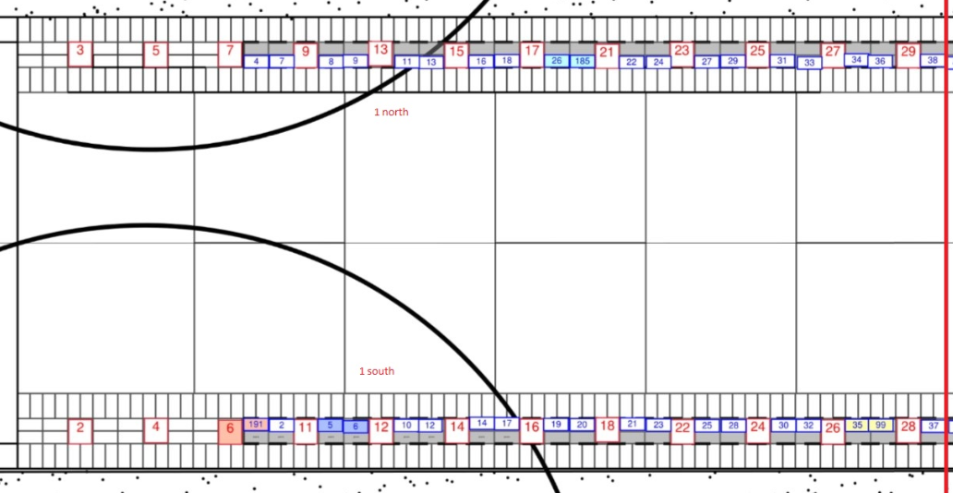

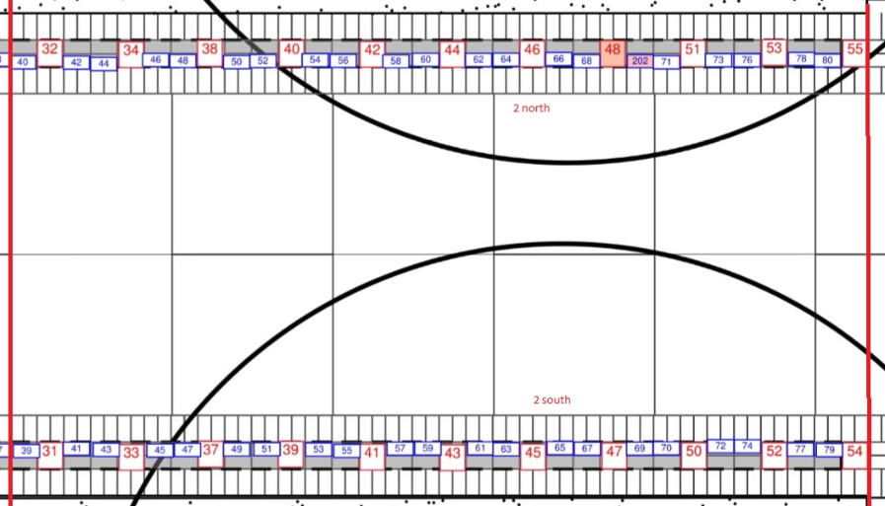

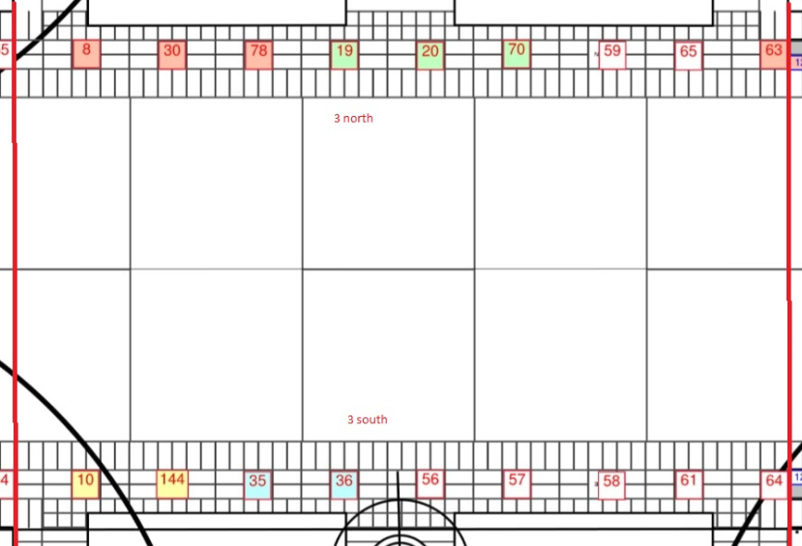

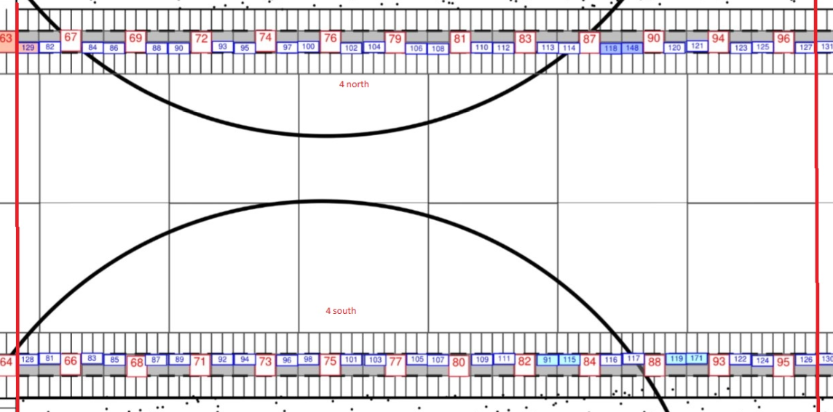

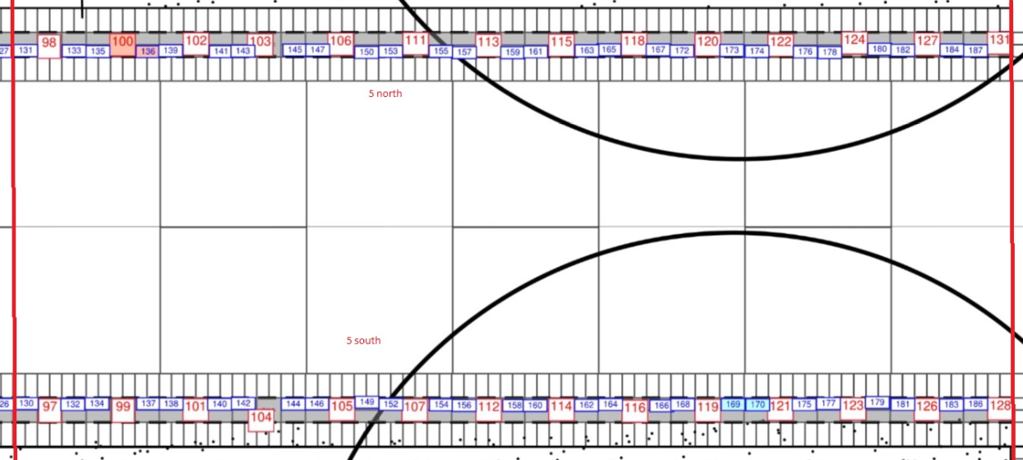

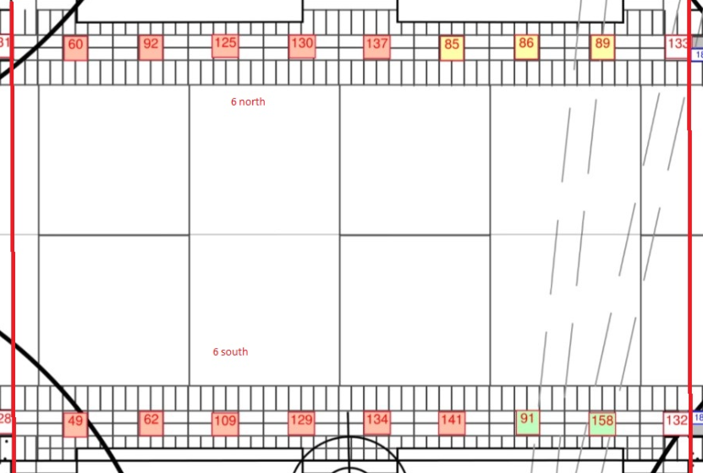

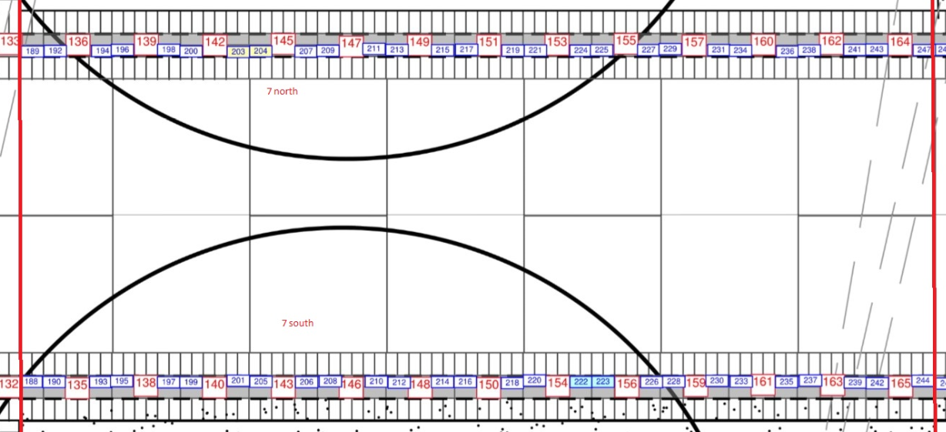

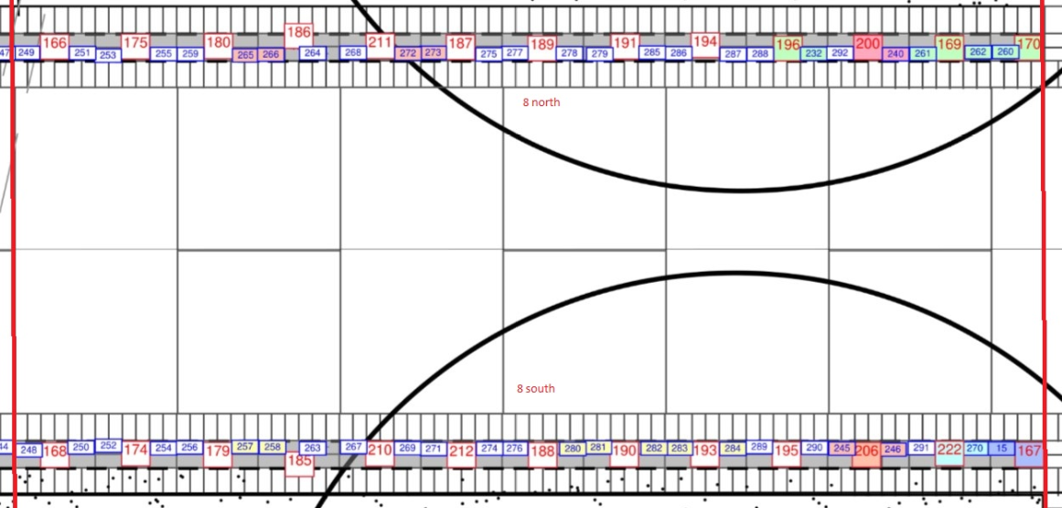

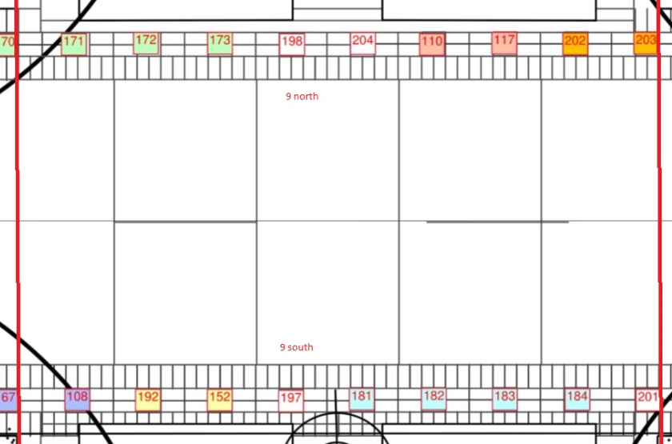

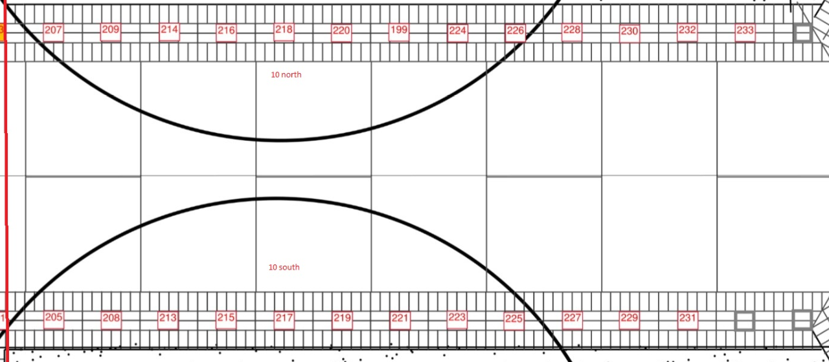

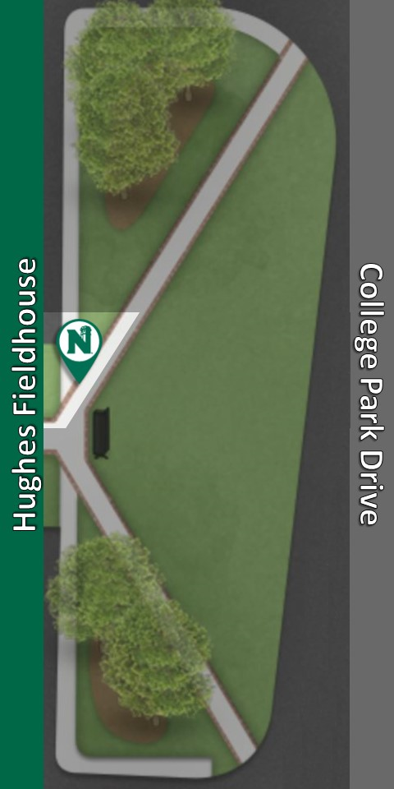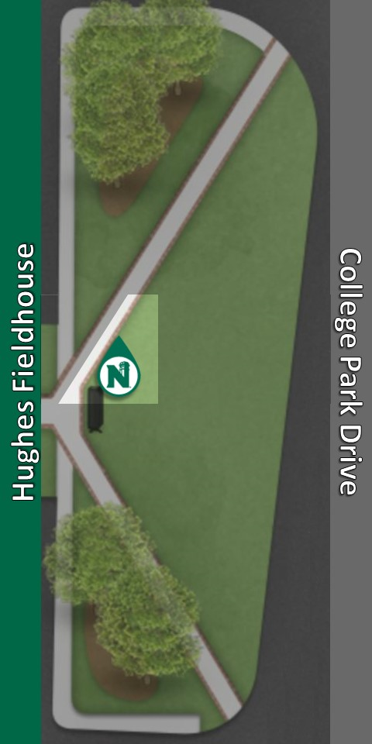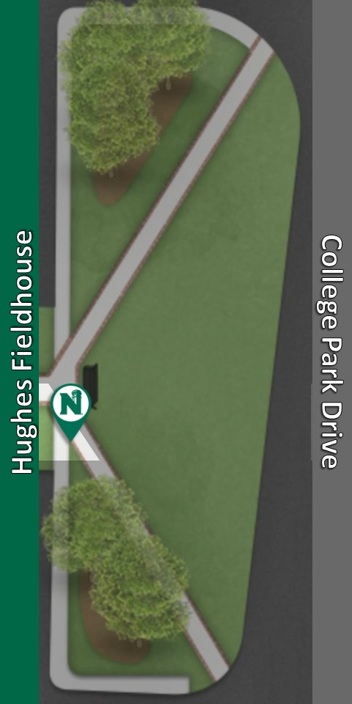

11NorthA 11NorthB 11SouthA

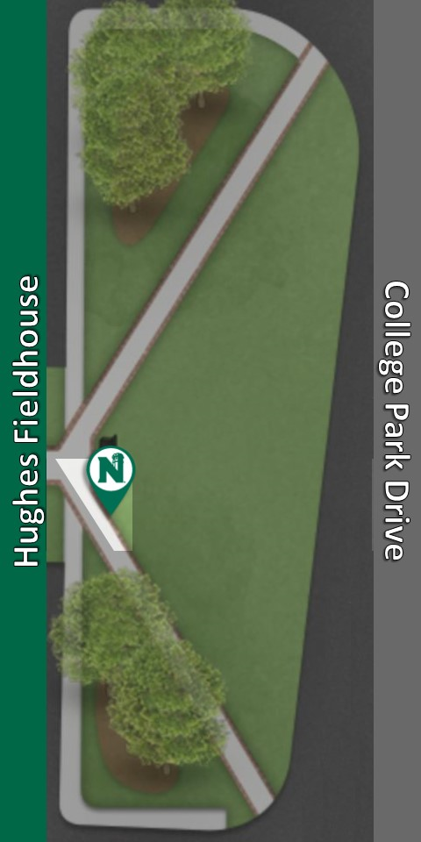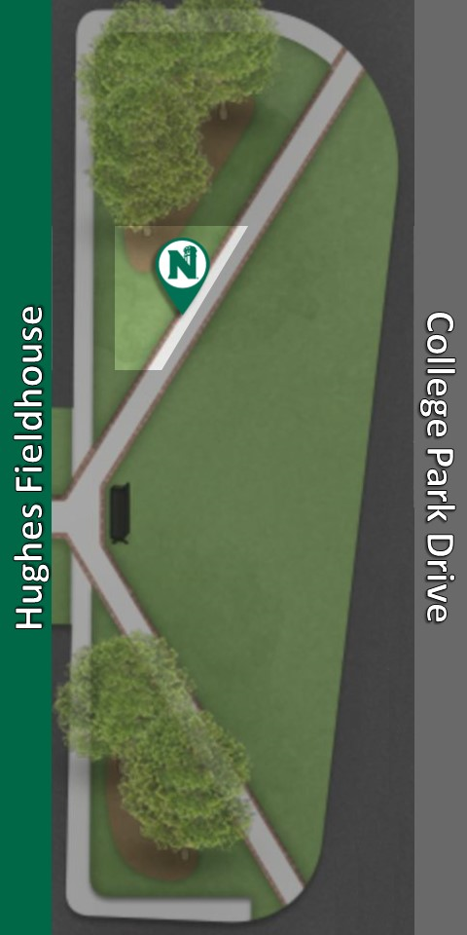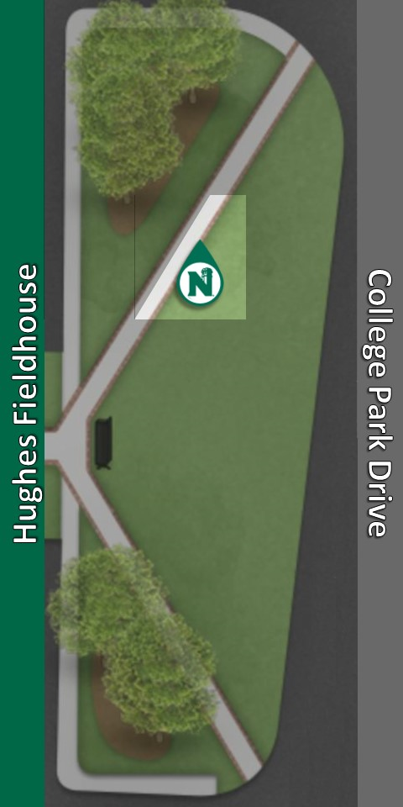

11SouthB 12NorthA 12NorthB

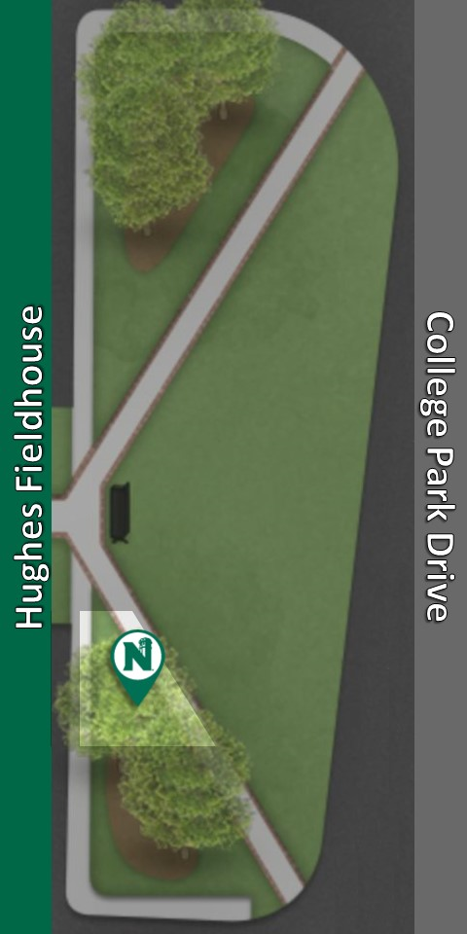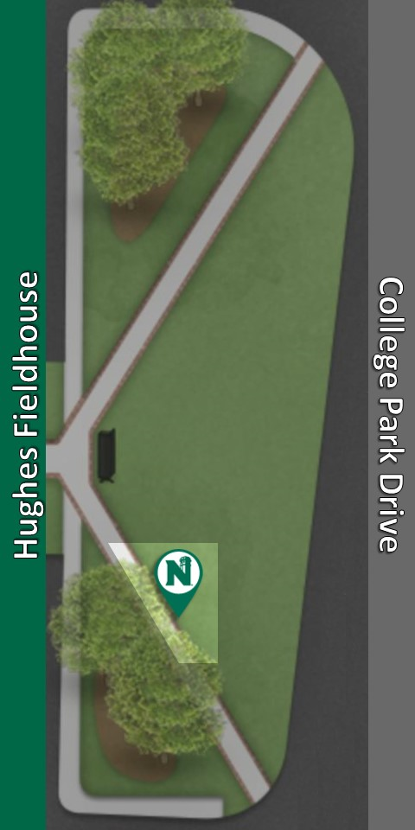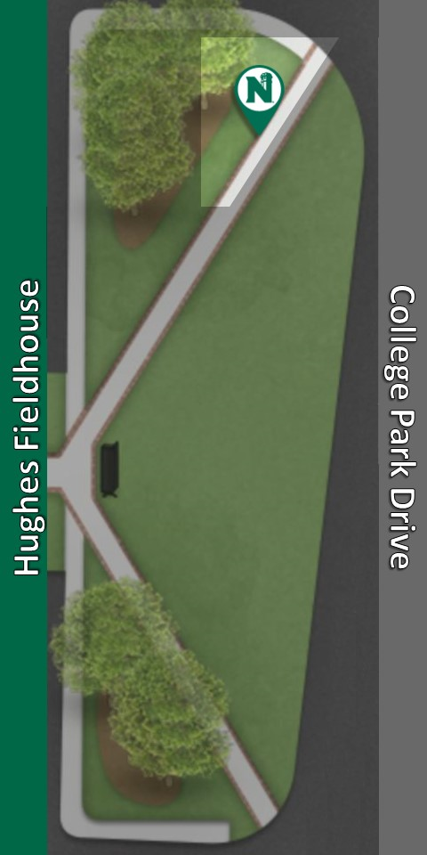

12SouthA 12SouthB 13NorthA

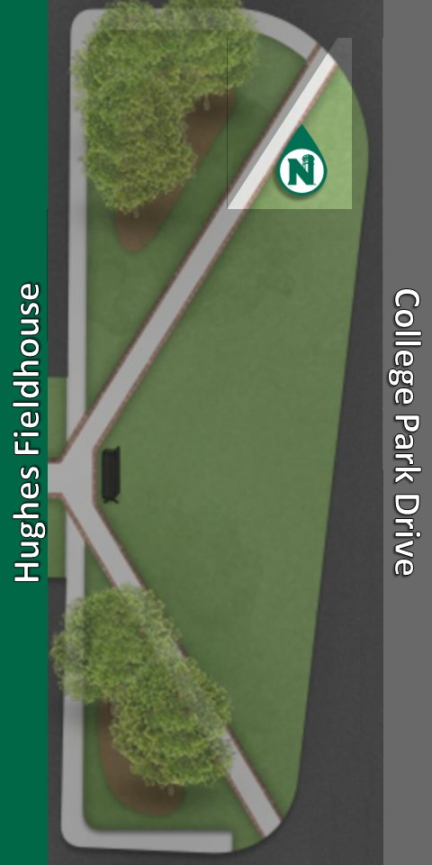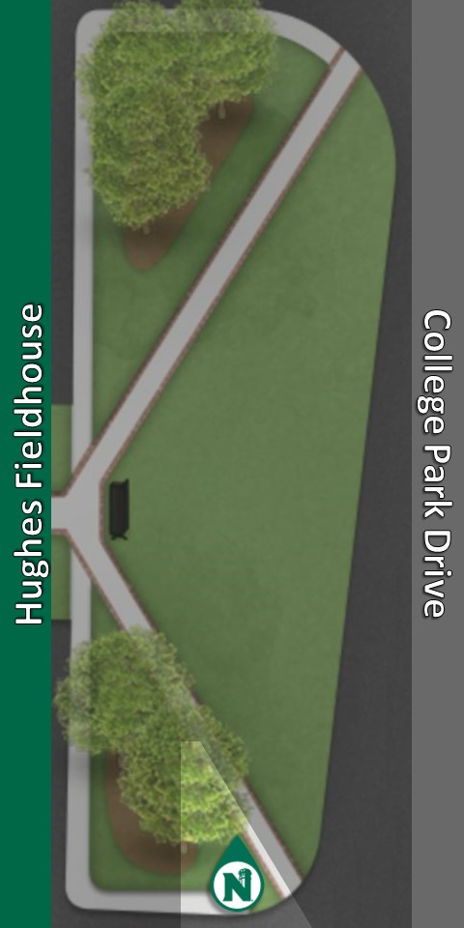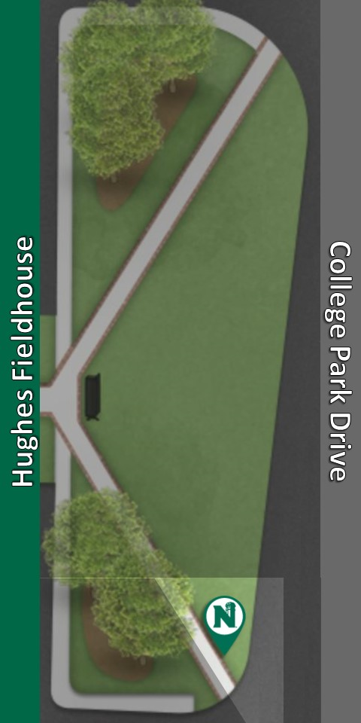

13NorthB 13SouthA 13SouthB